


James Spruce,
District Superintendent
VOL 62 NUMBER 1 P.O.BOX 1054 – 2916 GILBERT LN., ALTON, IL 62002 Web Site: http://ilnazarenedist.org SEPTEMBER 2008

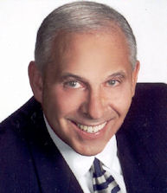
Lay Retreat
September 5th - 7th, 2008
“BEYOND SURVIVAL”
Dr. Chuck Millhuff

Changing Times
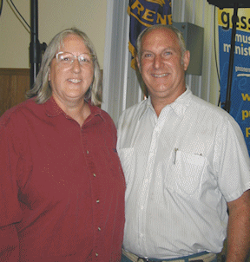

Our thanks is extended to Joe and Janet Thomas for six years of faithful service as managers of Nazarene Acres! As nearly everyone knows by now, the Thomas’s were offered a similar position on the West Texas District a few weeks ago and will move sometime after September 1st.
Joe and Janet did incredible work, putting in very long hours and offering a variety of skills and services that made our experience there all that it was. People are paid for their service, but they are loved and valued for their ministry. For the Thomas’s, Nazarene Acres was a ministry.
Because their departure coincides with the district advisory board’s evaluation of the future of our camp, the Board of Directors has determined to hire an interim camp manager on a temporary basis for the time being. All signed contracts will be honored.
The district advisory board is weighing its various options, and, with the Board of Directors, will assure continued management of the facility. At the present time we project that we will hold youth and children’s camps, conventions, assembly and camp meeting at the Acres next summer (2009). If the land is sold prior to next summer the plan is that we would negotiate with the purchaser to rent the facility for the summer events. Camp directors and auxiliary chairmen are fully aware of the uncertainty of our longer future at the Acres and are considering options for 2010.
Once again, on behalf of everyone, I am grateful for the Christlike manner in which assembly delegates dealt with the issue of giving the advisory board permission to determine the future ownership of this important property.
--Jim Spruce



NAZARENE MISSIONS INTERNATIONAL
Bill Brandon, District President
18 Sandstone Ct., Troy, IL. 62294
618-667-0828 E-mail csifsr30@sbcglobal.net
“That the world may know”

We had a very good NMI Convention July 18th. Thank you to everyone who worked so hard in putting it together. Praise goes to our Lord and Savior for letting the right decisions be made and for working out all the impossible problems. We serve a great God!

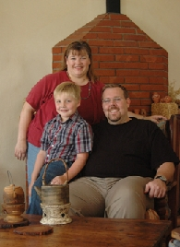
Our Fall Deputation Tour will be held October 8, 2008 to October 21, 2008 with the Utter’s. The schedule is being completed and is not available at the time of publication. We had a great time with them at our NMI Convention. Since the convention ended, there have been some exciting changes in their World assignment. You will want to hear what is going on so don’t miss this opportunity and attend the deputation service in your area! It turned out that Jacob broke his arm while at Nazarene Acres. You will want to hear his story. All I will tell you is it was not on his bicycle.
BIRTHDAYS
September 15 is our own missionary Rovina Hatcher’s birthday. She is serving in the Asia-Pacific region (Philippines) and is the daughter of Rev. Ed and Pat Retter who attend the Glenview Church where Pat serves as the NMI President.
Other September birthdays of Missionaries who have recently been on the Illinois District are Paul Martin serving the Africa Region (9/23) and Greg Taylor serving the Asia-Pacific Region (9/24).

Alabaster Offering
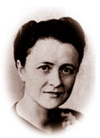
History of Alabaster Following World War II, the critical need for buildings and land in the world mission areas of the Church of the Nazarene was presented to the General NMI Council. The Council asked Rev. Elizabeth Roby Vennum, a member of the group, to submit a plan that would generate giving for this need.
Rev. Vennum knew if God wanted those buildings, He would provide the plan. On the return trip from Kansas City, God gave her His plan of giving "love" gifts. It was modeled after the sacrifice of the woman who anointed Jesus' head with expensive perfume poured from an alabaster jar (Matthew 26:6-13).
The General NMI Council unanimously adopted the plan, and the first offering was received in 1949. Now, more than 50 years later, more than 7,300 projects have been purchased or built with more than $79 million.
What is Alabaster
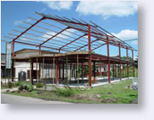
The Alabaster Offering provides funds for property and buildings around the world. It gives a sense of permanence, the attitude that the Church of the Nazarene intends to "put down roots." Eighty percent of the money is used in world mission areas, and twenty percent goes to multicultural congregations in the United States and Canada. Alabaster funds help provide land for most Work & Witness projects. The entire offering goes toward the construction of churches, schools, medical facilities, and homes for missionaries and national workers.

Alabaster should be well-publicized. All ages are encouraged to participate with leaders educating local churches as to the need for centers of holiness evangelism around the world.

NAZARENE YOUTH INTERNATIONAL
Jay Bush, District President
53 Partridge, Chatham, IL 62629
Phone: Church: 217-529-6771; Home: 217-483-2480
E-mail: jayrbush@aol.com


CONGRATULATIONS
to everyone who was elected at our
NYI Convention:
Jay Bush – President
Todd Holman- Vice President
Chris Shotts- Treasurer
Denis Payne- Secretary
Darren Breeden- Early Youth Rep
Cati Lourash- Early Youth Rep
Brad Deal- Sr. Youth Rep
Alex Hay- Sr. Youth Rep
Clara Stone- College Rep
Michael Toolen- College Rep

September 13, 2008 District Council Meeting
October 25, 2008 District Council Meeting
November 7-8, 2008 Spiritual Life Retreat (Done on Zones)
December 25, 2008 CHRISTMAS
February 6, 2009 District Council Meeting
February 7-8, 2009 Mid-Winter Retreat
April 3-4, 2009 District Celebrate Life
April 12, 2009 EASTER
April 18, 2009 District Council Meeting
May 7-9, 2009 Regional Celebrate Life
June 8-12, 2009 JH /SH Camp
2009 General NYI Convention Delegates were elected at our District Convention- They are as follows:
District President
Jay Bush
Ministerial
Todd Holman
Tim Cox
Wayne Clevenger- alternate
Brian Hay-alternate
Lay
Jamie Toolen
Tonya Deal
Nick Briggs- alternate
Jeff Hinkle- alternate
Youth
Brad Deal
Clara Stone
Jared Bouton- alternate
Katie McFee- alternate
June 24-July 3, 2009 General Conventions and Assembly
July 20-26 Family Camp
July 22-23 District Assembly
July 25 District NYI Convention

*ALL DATES SUBJECT TO CHANGE

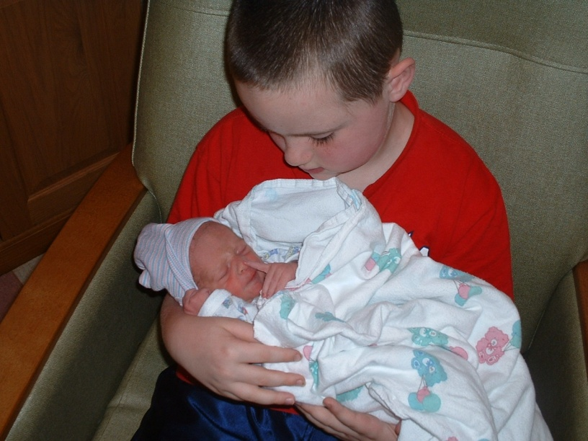
CONGRATULATIONS Todd and Amy Holman!


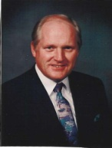
District Sunday School &
Discipleship Ministries International
JIM BLUE, District Chairman
5078 Olivet Rd., Georgetown, IL 61846
217-662-6924 E-mail: revjpb@aol.com


Elected to SDMI Board
( 3 year term )
Phyllis German
Rev. Mike Meyer
SUNDAY SCHOOL GROWTH AWARDS 2008

HONOR SCHOOLS: 5-24% increase SUPERIOR SCHOOLS; 25-49% increase
Anna, Belleville Emmanuel, Belleville First, Du Quoin, Arcola Spanish, Auburn, Carlinville and Carmi
Godfrey, Mt. Carmel, Mt. Erie, Murphysboro, Ogden,
Olney, Omaha and Springfield First. EXCEPTIONAL SCHOOLS; 50% and up
Beardstown Liberty and Urbana Lighthouse
2008 SUNDAY SCHOOLS OF THE YEAR:
Urbana Light House
2009 General SDMI Convention Delegates
Jim Blue, Chairman; Jerome Williams, Adult Ministries; Amy Holman, Children’s Ministries; Chris Blue, Judi Roarick and David Sorensen
+62 Responsibility List +44 Attendance
Beardstown Liberty
+ 145 % Responsibility List +150 % Attendance

2008 ASSEMBLY YEAR
TOP TEN IN GAINS
NUMERICAL INCREASE

Carmi 45
Urbana Lighthouse 44
Beardstown Liberty 21
Olivet 18
Salem 18
Belleville First 16
Auburn 15
Springfield First 14
Carlinville 13
Arcola Spanish 12

for your vote of confidence, the generous
love offering and the ILLINI Rocking Chair
presented to me at the conclusion of my
20th report as your District Chairman. Jim Blue
PERCENTAGE INCREASE

Beardstown Liberty 150
Rush Memorial 120
Urbana Lighthouse 118
Carmi 107
Carlinville 54
Barry 50
Auburn 37
Olivet 33
Arcola Spanish 28
Decatur Oak Grove 21

…to the many volunteers who worked our first Combined Children’s
Camp this year. Red Nose Ministry did a fantastic job ministering
to our children and staff. 141 children attended camp this year.
The date for next year’s camp will be JULY 27 – 31.

October 3 –4, 2008
Speaker:
Sue Ellen Rattin
Speaker: Sue Ellen Rattin

Sue Ellen will give women practical biblical instruction for managing their
time, talent, treasures and tears. REGISTRATION FORMS ARE ON THE DISTRICT WEB SITE. For more information call: 217-662-6924
f

SDMI REPORT APRIL 2008
Assembly Year '08 |  |  |  |  | Assembly Year '08
CHURCH | Enroll | SS | MW | NN | CHURCH | Enroll | SS | MW | NN
CHAMPAIGN TEAM: Carlos Lonberger, Chairman |  |  |  |  | Mount Vernon Team: Tim Mondy, Chairman
Champaign First | 197 | 93 | 112 | 3 | Benton | 88 | 44 | 58
Champaign New Day | 128 | 38 | 55 |  | Centralia | 135 | 59 | 62
Mahomet | 111 | 24 | 57 | 6 | Du Quoin | 42 | 20 | 24
Mansfield Community | 116 | 21 | 27 |  | Mount Vernon | 140 | 29 | 39
Monticello | 61 | 24 | 35 | 2 | Salem Grace | 365 | 176 | 316 | 29
Ogden | 67 | 50 | 68 | 8 | Sparta | 34 | 17 | 17
Rantoul | 81 | 47 | 87 | 3 | Tilden | 20 | 11 | 25
Urbana Lighthouse | 152 | 81 | 36 |  | MURPHYSBORO TEAM: Bobby Parker, Chairman
DECATUR TEAM: Greg Wooten, Chairman |  |  |  |  | Anna First | 193 | 94 | 106 | 16
Clinton | 176 | 80 | 108 | 4 | Carbondale New Beginnings | 97 | 46 | 59 | 6
Decatur First | 581 | 309 | 529 | 36 | Harrisburg | 60 | 16 | 21
Decatur Oak Grove | 198 | 26 | 46 | 2 | Marion | 48 | 29 | 36 | 3
Decatur Parkway | 200 | 90 | 103 |  | Metropolis | 20 | 15 | 20
Decatur Trinity | 113 | 38 | 47 |  | Murphysboro | 106 | 48 | 74
Decatur West Side | 181 | 90 | 108 | 3 | Omaha | 74 | 21 | 25 | 6
Lincoln | 112 | 23 | 45 |  | Royalton | 173 | 77 | 58
Shelbyville | 239 | 95 | 147 |  | OLIVET TEAM: Bill Connell, Chairman
ILLINOIS RIVER TEAM: Leslie Moore, Chairman |  |  |  |  | Chrisman | 98 | 52 | 80 | 9
Barry | 15 | 11 | 19 |  | Georgetown | 96 | 37 | 38 | 2
Beardstown | 151 | 86 | 101 | 1 | Home Gardens | 23 | 12 | 18
Beardstown Liberty | 71 | 35 | 40 |  | Oakwood | 48 | 28 | 9
Bethel Community | 100 | 53 | 75 | 5 | Olivet | 130 | 56 | 77 | 2
Griggsville | 76 | 26 | 37 |  | Paris | 25 | 15 | 45
Mount Sterling | 57 | 26 | 41 |  | Ridge Farm | 70 | 28 | 30
Nebo | 50 | 24 | 39 |  | Tuscola | 24 | 19 | 38
Pittsfield | 374 | 172 | 261 |  | OLNEY TEAM: Bob Taylor, Chairman
Quincy Emmanuel | 66 | 34 | 60 |  | Carmi | 59 | 48 | 48 | 1
MATTOON TEAM: Penny Brown, Chairman |  |  |  |  | Fairfield | 24 | 14 | 19
Arcola First | 99 | 45 | 46 |  | Flora | 219 | 143 | 174
Arcola Spanish | 76 | 40 | 58 |  | Laclede | 52 | 10 | 12
Casey | 717 | 102 | 210 | 3 | Lawrenceville Faith | 31 | 15 | 23
Marshall | 182 | 59 | 53 | 1 | Mount Carmel | 42 | 21 | 31
Mattoon East Side | 199 | 95 | 112 | 7 | Mount Erie | 70 | 25 | 28 | 3
Mattoon Real Life Community | 82 | 38 | 60 |  | Olney | 189 | 75 | 101
West Union | 65 | 29 | 37 |  | SPRINGFIELD TEAM: Donald Harrison, Chairman
METRO EAST TEAM: Russell Brewer, Chairman |  |  |  |  | Auburn | 305 | 56 | 57 | 17
Belleville Emmanuel | 95 | 41 | 37 | 3 | Carlinville | 56 | 37 | 37 | 5
Belleville First | 282 | 162 | 206 | 1 | Pana | 352 | 153 | 301 | 23
Belleville Korean | 41 | 16 | 40 | 3 | Sherman | 147 | 72 | 88 | 3
Bluffview Christian Center | 161 | 28 | 51 | 1 | Springfield First | 293 | 195 | 260 | 12
Collinsville Good Samaratin | 252 | 77 | 182 | 2 | Springfield Trinity | 137 | 41 | 71 | 2
East St. Louis Rush Memorial | 6 | 5 | 5 | 1 | Taylorville | 95 | 45 | 55 | 1
Edgemont Grace | 66 | 23 | 33 | 1 | Virden | 60 | 28 | 28 | 1
Fairview Heights Parkview | 94 | 56 | 55
Mississippi Valley Team: Richard Unger, Chairman
Glenview | 181 | 66 | 62 | 3
Godfrey | 196 | 58 | 88 |  | GRAND TOTALS | 11355 | 4707 | 6608 | 258
Granite City Crossroads | 75 | 29 | 57 |  |  | RESP | SS | AM | NN
Jerseyville | 117 | 39 | 48 | 2
Roxana | 362 | 167 | 150 | 8
BUDGET REPORT as of JUNE 30, 2008
Church Name | Unified | % Paid | Olivet | % Paid | NMI | % Paid | SDMI | % Paid | NYI | % Paid | WEF | % Paid | P & B | % Paid
Anna First | $10,954.00 | 0.00% | $6,303.00 | 0.00% | $551.00 | 0.00% | $524.00 | 0.00% | $557.00 | 0.00% | $13,507.00 | 0.00% | $3,602.00 | 0.00%
Arcola First | $3,577.00 | 0.00% | $2,058.00 | 0.00% | $180.00 | 0.00% | $171.00 | 0.00% | $182.00 | 0.00% | $4,410.00 | 0.00% | $1,176.00 | 0.00%
Arcola Spanish | $704.00 | 0.00% | $405.00 | 0.00% | $35.00 | 0.00% | $34.00 | 0.00% | $36.00 | 0.00% | $868.00 | 0.00% | $231.00 | 0.00%
Auburn | $5,169.00 | 0.00% | $2,974.00 | 0.00% | $260.00 | 0.00% | $247.00 | 0.00% | $263.00 | 0.00% | $6,373.00 | 0.00% | $1,699.00 | 0.00%
Barry | $1,057.00 | 0.00% | $608.00 | 0.00% | $53.00 | 0.00% | $51.00 | 0.00% | $54.00 | 0.00% | $1,303.00 | 0.00% | $347.00 | 0.00%
Beardstown | $8,884.00 | 0.00% | $5,112.00 | 0.00% | $447.00 | 0.00% | $425.00 | 0.00% | $452.00 | 0.00% | $10,954.00 | 0.00% | $2,921.00 | 0.00%
Beardstown Liberty Hispanic | $2,450.00 | 0.00% | $1,410.00 | 0.00% | $123.00 | 0.00% | $117.00 | 0.00% | $125.00 | 0.00% | $3,020.00 | 0.00% | $806.00 | 0.00%
Belleville Emmanuel | $3,285.00 | 0.00% | $1,890.00 | 0.00% | $165.00 | 0.00% | $157.00 | 0.00% | $167.00 | 0.00% | $4,051.00 | 0.00% | $1,080.00 | 0.00%
Belleville First | $19,994.00 | 0.00% | $11,505.00 | 0.00% | $1,006.00 | 0.00% | $957.00 | 0.00% | $1,017.00 | 0.00% | $24,654.00 | 0.00% | $6,574.00 | 0.00%
Belleville Korean | $7,097.00 | 11.78% | $4,084.00 | 12.44% | $357.00 | 0.00% | $340.00 | 0.00% | $361.00 | 0.00% | $8,752.00 | 0.00% | $2,334.00 | 0.00%
Benton First | $5,727.00 | 0.00% | $3,295.00 | 0.00% | $288.00 | 0.00% | $274.00 | 0.00% | $291.00 | 0.00% | $7,062.00 | 0.00% | $1,883.00 | 0.00%
Bethel | $4,692.00 | 0.00% | $2,700.00 | 0.00% | $236.00 | 0.00% | $224.00 | 0.00% | $239.00 | 0.00% | $5,786.00 | 0.00% | $1,543.00 | 0.00%
Carlinville First | $2,060.00 | 0.00% | $1,185.00 | 0.00% | $104.00 | 0.00% | $99.00 | 0.00% | $105.00 | 0.00% | $2,540.00 | 0.00% | $678.00 | 0.00%
Carmi | $3,133.00 | 0.00% | $1,803.00 | 0.00% | $157.00 | 0.00% | $150.00 | 0.00% | $159.00 | 0.00% | $3,864.00 | 0.00% | $1,030.00 | 0.00%
Casey | $25,797.00 | 18.24% | $14,844.00 | 38.40% | $1,298.00 | 0.00% | $1,234.00 | 0.00% | $1,313.00 | 0.00% | $31,809.00 | 0.00% | $8,482.00 | 0.00%
Centralia | $5,094.00 | 0.00% | $2,931.00 | 0.00% | $257.00 | 0.00% | $244.00 | 0.00% | $260.00 | 0.00% | $6,282.00 | 0.00% | $1,675.00 | 0.00%
Champaign First | $11,599.00 | 34.49% | $6,674.00 | 0.00% | $584.00 | 0.00% | $555.00 | 0.00% | $590.00 | 0.00% | $14,302.00 | 0.00% | $3,814.00 | 0.00%
Champaign New Day | $5,437.00 | 0.00% | $3,129.00 | 0.00% | $274.00 | 0.00% | $260.00 | 0.00% | $276.00 | 0.00% | $6,705.00 | 0.00% | $1,788.00 | 0.00%
Chrisman | $6,957.00 | 0.00% | $4,003.00 | 0.00% | $350.00 | 0.00% | $333.00 | 0.00% | $354.00 | 0.00% | $8,578.00 | 0.00% | $2,287.00 | 0.00%
Clinton First | $11,811.00 | 8.47% | $6,796.00 | 7.36% | $594.00 | 0.00% | $565.00 | 0.00% | $601.00 | 0.00% | $14,564.00 | 0.00% | $3,884.00 | 0.00%
Collinsville First | $15,185.00 | 13.17% | $8,738.00 | 17.17% | $764.00 | 0.00% | $727.00 | 4.68% | $773.00 | 1.55% | $18,724.00 | 0.00% | $4,993.00 | 0.00%
Decatur First | $30,341.00 | 8.24% | $17,459.00 | 29.34% | $1,526.00 | 0.00% | $1,452.00 | 0.00% | $1,544.00 | 0.00% | $37,412.00 | 0.00% | $9,976.00 | 0.00%
Decatur Oak Grove | $3,266.00 | 0.00% | $1,880.00 | 0.00% | $164.00 | 0.00% | $156.00 | 0.00% | $166.00 | 0.00% | $4,028.00 | 0.00% | $1,074.00 | 0.00%
Decatur Parkway | $14,533.00 | 0.00% | $8,363.00 | 0.00% | $731.00 | 0.00% | $695.00 | 0.00% | $740.00 | 0.00% | $17,921.00 | 0.00% | $4,779.00 | 0.00%
Decatur Trinity | $5,993.00 | 0.00% | $3,449.00 | 0.00% | $302.00 | 0.00% | $287.00 | 0.00% | $305.00 | 0.00% | $7,390.00 | 0.00% | $1,971.00 | 0.00%
Decatur West Side | $13,156.00 | 0.00% | $7,570.00 | 0.00% | $662.00 | 0.00% | $629.00 | 0.00% | $670.00 | 0.00% | $16,221.00 | 0.00% | $4,325.00 | 0.00%
Du Quoin | $1,580.00 | 18.99% | $909.00 | 0.00% | $79.00 | 0.00% | $76.00 | 0.00% | $80.00 | 0.00% | $1,948.00 | 0.00% | $520.00 | 0.00%
Bluff View Christian Center | $4,092.00 | 0.00% | $2,355.00 | 0.00% | $206.00 | 0.00% | $196.00 | 0.00% | $208.00 | 0.00% | $5,046.00 | 0.00% | $1,346.00 | 0.00%
East St. Louis Rush Mem. | $504.00 | 0.00% | $290.00 | 0.00% | $26.00 | 0.00% | $24.00 | 0.00% | $26.00 | 0.00% | $622.00 | 0.00% | $166.00 | 0.00%
Edgemont Grace | $1,893.00 | 0.00% | $1,089.00 | 0.00% | $96.00 | 0.00% | $90.00 | 0.00% | $96.00 | 0.00% | $2,335.00 | 0.00% | $622.00 | 0.00%
Laclede | $773.00 | 0.00% | $445.00 | 0.00% | $39.00 | 0.00% | $37.00 | 0.00% | $39.00 | 0.00% | $953.00 | 0.00% | $254.00 | 0.00%
Fairfield | $1,634.00 | 0.00% | $940.00 | 0.00% | $83.00 | 0.00% | $78.00 | 0.00% | $83.00 | 0.00% | $2,014.00 | 0.00% | $537.00 | 0.00%
Fairview Heights Parkview | $6,670.00 | 12.00% | $3,838.00 | 0.00% | $336.00 | 0.00% | $319.00 | 50.36% | $339.00 | 47.39% | $8,225.00 | 0.00% | $2,193.00 | 0.00%
Flora | $12,113.00 | 0.00% | $6,970.00 | 0.00% | $609.00 | 0.00% | $579.00 | 0.00% | $616.00 | 0.00% | $14,935.00 | 0.00% | $3,982.00 | 0.00%
Georgetown | $3,941.00 | 0.00% | $2,268.00 | 0.00% | $198.00 | 0.00% | $188.00 | 0.00% | $200.00 | 0.00% | $4,859.00 | 0.00% | $1,296.00 | 0.00%
Glenview | $7,636.00 | 0.00% | $4,394.00 | 0.00% | $384.00 | 0.00% | $365.00 | 0.00% | $389.00 | 0.00% | $9,415.00 | 0.00% | $2,511.00 | 0.00%
Godfrey | $7,471.00 | 17.40% | $4,299.00 | 0.00% | $376.00 | 0.00% | $357.00 | 0.00% | $380.00 | 0.00% | $9,212.00 | 0.00% | $2,457.00 | 0.00%
Good Samaritan Ministry | $122.00 | 0.00% | $70.00 | 0.00% | $6.00 | 0.00% | $6.00 | 0.00% | $6.00 | 0.00% | $150.00 | 0.00% | $40.00 | 0.00%
Crossroads Community | $6,987.00 | 0.00% | $4,021.00 | 0.00% | $352.00 | 0.00% | $334.00 | 0.00% | $355.00 | 0.00% | $8,616.00 | 0.00% | $2,297.00 | 0.00%
Griggsville | $2,240.00 | 0.00% | $1,290.00 | 0.00% | $113.00 | 0.00% | $107.00 | 0.00% | $114.00 | 0.00% | $2,762.00 | 0.00% | $736.00 | 0.00%
Harrisburg First | $2,306.00 | 0.00% | $1,327.00 | 0.00% | $116.00 | 0.00% | $110.00 | 0.00% | $118.00 | 0.00% | $2,844.00 | 0.00% | $758.00 | 0.00%
Highland | $122.00 | 0.00% | $70.00 | 0.00% | $6.00 | 0.00% | $6.00 | 0.00% | $6.00 | 0.00% | $150.00 | 0.00% | $40.00 | 0.00%
Home Gardens | $765.00 | 0.00% | $440.00 | 0.00% | $38.00 | 0.00% | $36.00 | 0.00% | $39.00 | 0.00% | $943.00 | 0.00% | $251.00 | 0.00%
Jerseyville | $2,136.00 | 0.00% | $1,229.00 | 0.00% | $107.00 | 0.00% | $102.00 | 0.00% | $109.00 | 0.00% | $2,634.00 | 0.00% | $702.00 | 0.00%
Lawrenceville Faith | $1,440.00 | 0.00% | $829.00 | 0.00% | $73.00 | 0.00% | $69.00 | 0.00% | $73.00 | 0.00% | $1,776.00 | 0.00% | $473.00 | 0.00%
Lincoln First | $1,872.00 | 16.03% | $1,077.00 | 23.21% | $94.00 | 0.00% | $90.00 | 0.00% | $95.00 | 0.00% | $2,308.00 | 0.00% | $615.00 | 0.00%
Mahomet | $4,140.00 | 0.00% | $2,382.00 | 0.00% | $208.00 | 0.00% | $198.00 | 0.00% | $211.00 | 0.00% | $5,104.00 | 0.00% | $1,361.00 | 0.00%
Mansfield | $3,425.00 | 12.41% | $1,971.00 | 12.68% | $172.00 | 0.00% | $164.00 | 0.00% | $174.00 | 0.00% | $4,223.00 | 0.00% | $1,126.00 | 0.00%
Marion | $4,909.00 | 0.00% | $2,825.00 | 0.00% | $247.00 | 0.00% | $235.00 | 0.00% | $250.00 | 0.00% | $6,053.00 | 0.00% | $1,614.00 | 0.00%
Oasis Community | $122.00 | 0.00% | $70.00 | 0.00% | $6.00 | 0.00% | $6.00 | 0.00% | $6.00 | 0.00% | $150.00 | 0.00% | $40.00 | 0.00%
Marshall | $4,520.00 | 0.00% | $2,601.00 | 0.00% | $227.00 | 0.00% | $216.00 | 0.00% | $230.00 | 0.00% | $5,574.00 | 0.00% | $1,486.00 | 0.00%
Mattoon East Side | $7,967.00 | 0.00% | $4,585.00 | 0.00% | $401.00 | 0.00% | $381.00 | 0.00% | $406.00 | 0.00% | $9,825.00 | 0.00% | $2,620.00 | 0.00%
Mattoon Real Life Community | $7,941.00 | 0.00% | $4,569.00 | 0.00% | $399.00 | 0.00% | $380.00 | 0.00% | $404.00 | 0.00% | $9,791.00 | 0.00% | $2,611.00 | 0.00%
Metropolis | $577.00 | 0.00% | $332.00 | 0.00% | $29.00 | 0.00% | $28.00 | 0.00% | $29.00 | 0.00% | $711.00 | 0.00% | $190.00 | 0.00%
Monticello | $5,803.00 | 3.58% | $3,339.00 | 6.23% | $292.00 | 0.00% | $277.00 | 0.00% | $295.00 | 0.00% | $7,156.00 | 0.00% | $1,909.00 | 0.00%
Mt. Carmel | $2,271.00 | 0.00% | $1,307.00 | 0.00% | $114.00 | 0.00% | $109.00 | 0.00% | $116.00 | 0.00% | $2,800.00 | 0.00% | $747.00 | 0.00%
Mt. Erie | $3,287.00 | 10.65% | $1,891.00 | 18.51% | $165.00 | 0.00% | $157.00 | 0.00% | $167.00 | 0.00% | $4,053.00 | 0.00% | $1,081.00 | 0.00%
Mt. Sterling | $2,798.00 | 48.53% | $1,610.00 | 0.00% | $141.00 | 0.00% | $134.00 | 0.00% | $142.00 | 0.00% | $3,451.00 | 0.00% | $920.00 | 0.00%
Mt. Vernon Faith | $2,983.00 | 8.26% | $1,716.00 | 8.34% | $150.00 | 0.00% | $143.00 | 7.76% | $152.00 | 7.63% | $3,678.00 | 0.00% | $981.00 | 0.00%
Murphysboro | $7,213.00 | 0.00% | $4,150.00 | 0.00% | $363.00 | 0.00% | $345.00 | 0.00% | $367.00 | 0.00% | $8,894.00 | 0.00% | $2,372.00 | 0.00%
Nebo | $2,767.00 | 0.00% | $1,592.00 | 31.41% | $139.00 | 0.00% | $132.00 | 0.00% | $141.00 | 0.00% | $3,412.00 | 0.00% | $910.00 | 0.00%
New Beginnings Comm. Church | $1,664.00 | 0.00% | $958.00 | 0.00% | $84.00 | 0.00% | $80.00 | 0.00% | $85.00 | 0.00% | $2,052.00 | 0.00% | $547.00 | 0.00%
Oakwood | $992.00 | 0.00% | $571.00 | 0.00% | $50.00 | 0.00% | $47.00 | 0.00% | $50.00 | 0.00% | $1,223.00 | 0.00% | $326.00 | 0.00%
Ogden | $6,855.00 | 0.00% | $3,945.00 | 0.00% | $345.00 | 0.00% | $328.00 | 0.00% | $349.00 | 0.00% | $8,453.00 | 0.00% | $2,254.00 | 0.00%
Olivet | $4,211.00 | 0.00% | $2,423.00 | 0.00% | $212.00 | 0.00% | $201.00 | 0.00% | $214.00 | 0.00% | $5,193.00 | 0.00% | $1,385.00 | 0.00%
Olney | $7,156.00 | 0.00% | $4,118.00 | 7.29% | $360.00 | 0.00% | $342.00 | 0.00% | $364.00 | 0.00% | $8,824.00 | 0.00% | $2,353.00 | 0.00%
Omaha | $1,469.00 | 0.00% | $845.00 | 0.00% | $74.00 | 0.00% | $70.00 | 0.00% | $75.00 | 0.00% | $1,811.00 | 0.00% | $483.00 | 0.00%
Pana First | $8,293.00 | 0.00% | $4,772.00 | 0.00% | $417.00 | 0.00% | $397.00 | 0.00% | $422.00 | 0.00% | $10,225.00 | 0.00% | $2,727.00 | 0.00%
Paris First | $3,176.00 | 0.00% | $1,828.00 | 0.00% | $160.00 | 0.00% | $152.00 | 0.00% | $161.00 | 0.00% | $3,916.00 | 0.00% | $1,044.00 | 0.00%
Pittsfield | $26,945.00 | 25.98% | $15,505.00 | 38.70% | $1,356.00 | 0.00% | $1,289.00 | 0.00% | $1,371.00 | 0.00% | $33,225.00 | 0.00% | $8,860.00 | 0.00%
Quincy Emmanuel | $4,064.00 | 0.00% | $2,339.00 | 0.00% | $204.00 | 0.00% | $194.00 | 0.00% | $207.00 | 0.00% | $5,011.00 | 0.00% | $1,336.00 | 0.00%
Rantoul | $8,463.00 | 9.60% | $4,870.00 | 11.12% | $426.00 | 0.00% | $405.00 | 0.00% | $431.00 | 0.00% | $10,435.00 | 0.00% | $2,783.00 | 0.00%
Ridge Farm | $2,141.00 | 10.23% | $1,232.00 | 22.56% | $108.00 | 0.00% | $102.00 | 0.00% | $109.00 | 0.00% | $2,639.00 | 0.00% | $704.00 | 0.00%
Roxana | $19,758.00 | 11.86% | $11,370.00 | 0.00% | $994.00 | 0.00% | $945.00 | 0.00% | $1,005.00 | 0.00% | $24,363.00 | 0.00% | $6,497.00 | 0.00%
Royalton First | $5,358.00 | 0.00% | $3,083.00 | 0.00% | $270.00 | 0.00% | $256.00 | 0.00% | $273.00 | 0.00% | $6,607.00 | 0.00% | $1,762.00 | 0.00%
Salem Grace | $22,301.00 | 6.73% | $12,832.00 | 11.69% | $1,122.00 | 0.00% | $1,067.00 | 0.00% | $1,135.00 | 0.00% | $27,498.00 | 0.00% | $7,333.00 | 0.00%
Shelbyville | $14,068.00 | 0.00% | $8,094.00 | 0.00% | $708.00 | 0.00% | $673.00 | 0.00% | $716.00 | 0.00% | $17,346.00 | 0.00% | $4,626.00 | 0.00%
Sparta | $980.00 | 0.00% | $564.00 | 0.00% | $49.00 | 0.00% | $47.00 | 0.00% | $50.00 | 0.00% | $1,208.00 | 0.00% | $322.00 | 0.00%
Springfield First | $24,403.00 | 0.00% | $14,042.00 | 0.00% | $1,228.00 | 0.00% | $1,168.00 | 0.00% | $1,242.00 | 0.00% | $30,090.00 | 0.00% | $8,024.00 | 0.00%
Sherman | $8,934.00 | 0.00% | $5,141.00 | 0.00% | $449.00 | 0.00% | $427.00 | 0.00% | $455.00 | 0.00% | $11,016.00 | 0.00% | $2,938.00 | 0.00%
Springfield Trinity | $6,586.00 | 0.00% | $3,790.00 | 0.00% | $332.00 | 0.00% | $315.00 | 0.00% | $335.00 | 0.00% | $8,121.00 | 0.00% | $2,166.00 | 0.00%
Taylorville First | $3,840.00 | 0.00% | $2,210.00 | 0.00% | $193.00 | 0.00% | $184.00 | 0.00% | $195.00 | 0.00% | $4,735.00 | 0.00% | $1,262.00 | 0.00%
Tilden | $1,438.00 | 0.00% | $827.00 | 0.00% | $72.00 | 0.00% | $69.00 | 0.00% | $73.00 | 0.00% | $1,773.00 | 0.00% | $473.00 | 0.00%
Tuscola | $3,291.00 | 0.00% | $1,894.00 | 0.00% | $166.00 | 0.00% | $157.00 | 0.00% | $167.00 | 0.00% | $4,059.00 | 0.00% | $1,082.00 | 0.00%
Urbana Lighthouse | $437.00 | 0.00% | $252.00 | 0.00% | $22.00 | 0.00% | $21.00 | 0.00% | $22.00 | 0.00% | $539.00 | 0.00% | $144.00 | 0.00%
Virden | $2,701.00 | 0.00% | $1,554.00 | 0.00% | $136.00 | 0.00% | $129.00 | 0.00% | $137.00 | 0.00% | $3,330.00 | 0.00% | $888.00 | 0.00%
Vandalia | $122.00 | 0.00% | $70.00 | 0.00% | $6.00 | 0.00% | $6.00 | 0.00% | $6.00 | 0.00% | $150.00 | 0.00% | $40.00 | 0.00%
West Union | $772.00 | 0.00% | $444.00 | 0.00% | $39.00 | 0.00% | $37.00 | 0.00% | $39.00 | 0.00% | $952.00 | 0.00% | $254.00 | 0.00%
Totals | $545,390.00 | 5.90% | $313,831.00 | 7.54% | $27,440.00 | 0.59% | $26,089.00 | 0.79% | $27,749.00 | 0.66% | $672,496.00 | 0.00% | $179,329.00 | 0.00%



Missional Strategy
MARK COPLEY, District Missionary
P.O. Box 373, Casey, IL 62420
Office: 217-932-4522; Cell:
E-mail: pastor@kznaz.org

Time to Pray

Jesus told them, "The harvest is plentiful, but the workers are few. Ask the Lord of the harvest, therefore, to send out workers into his harvest field. – Luke 10:02

The mission of the Illinois District is challenging to say the least. In a postmodern culture where morality is up for grabs, pastors are discouraged, and many churches are in decline -- we have been called to “develop healthy, holiness pastors and churches that multiply.” To do so, we will have to overcome not only the gravity of our past ways of doing things, but also about a quarter century of “consumer Christianity” -- which has produced sanctuaries full of religious clients, but hardly a handful of disciples. There is then not only a culture outside our churches that must be redeemed, but a culture among our churches that must be transformed. I believe Christ wants to accomplish his mission among us with “Pentecostal effectiveness” – a spiritual movement which will result in the revival of congregations and the multiplication of new churches across our District. A generation will be changed by this movement. Children, families, and communities wait to be transformed by the power of Christ. Isn’t that the vision of Jesus? He always sees a harvest field that is plentiful.
I’m not sure I know the path to get there, but I know where the journey begins. It begins with prayer. When Jesus was getting ready to send his disciples into the villages of his home district, he called them to take the first step on their knees. “Ask the Lord of the harvest,” he says, “to send out workers into his harvest field.”
This has become my daily prayer as I consider the mission of our District – your mission and mine. That God – who rules over the harvest – will raise up, and send forth workers to accomplish this mission, and fulfill his vision. I pray this prayer several times daily, but I consistently pray it at 10:02am, which reminds me of Jesus words in Luke 10:02. I do this by setting my cellphone alarm to ring at 10:02am.
Now there are mighty prayers that once prayed are instantly answered with obvious results. I’m sure you’ve witnessed some of those. But there are also small prayers, that are mighty nonetheless. I call them “snowflake prayers.” Nothing seems as small and fragile as a snowflake – catch one on your finger or tongue, and it will disappear immediately. But let them pile up and they will stop the school busses for the day. Let them pile up some more and you may get an avalanche that can bury a village.
What if hundreds of us across the Illinois District all bowed our heads daily at 10:02am to ask the Lord of the harvest to send workers into our District’s harvest field? I believe such a small act of prayer, multiplied many times, might cover our District with the glory of God, and prepare the way for the workers that Christ is already preparing to send.
Would you join me in this ministry of prayer? Set your alarm clock, your watch, or cellphone for 10:02am, and when it sounds, hear it as a call to prayer. These prayers will unite us in our mission, open the doors for new workers, and prepare each of us to do our part in the harvest as well.
Tomorrow morning and each day following, I hope you hear the Spirit’s voice whisper, “It’s 10:02am. Do you know where the workers are?”
- Mark Copley
District Missionary

CHURCH NEWS

OLIVET 7-30-08

Rev. Haynes,

Just dropping you a note to let you know that the Olivet church board met on Sunday afternoon and we had a very good board meeting. The church board approved a raise of $20 per week which represents a 5.4% cost of living raise. The board also voted on where we think our new ramp should be placed so that we could get a drawing and then an estimate on what the cost would be.

These are exciting times for the Olivet Church. We are seeing more new faces coming to church and the Spirit of the Lord can be felt in every service. We at the Olivet Church love and appreciate everything Pastor Blue and Chris do in the church as well as in the surrounding community.

Just thought you would like to know.

JaNell Stark
Church Board Secretary

CHRISMAN 6-24-08
These are good days at Chrisman Church of the Nazarene. Sunday evening June 22nd Marge Lewsader, Wyatt Humrichous, and Anna Humrichous shared their testimonies before being baptized. And then Monday morning we loaded up 18 teens and sent them to camp. We are praising the Lord for His goodness and His presence. - Pastor Chris Hughes

7-1-08
Junior High and High School camp was a great time for our Church. Eighteen teens made their way to Nazarene Acres and the Sunday they returned it was obvious God had worked in a special way. All of them were impacted in some way several saved for the first time. We praise the Lord for what he is doing in the lives of our teens.

Pastor Chris Hughes
Chrisman Church of the Nazarene

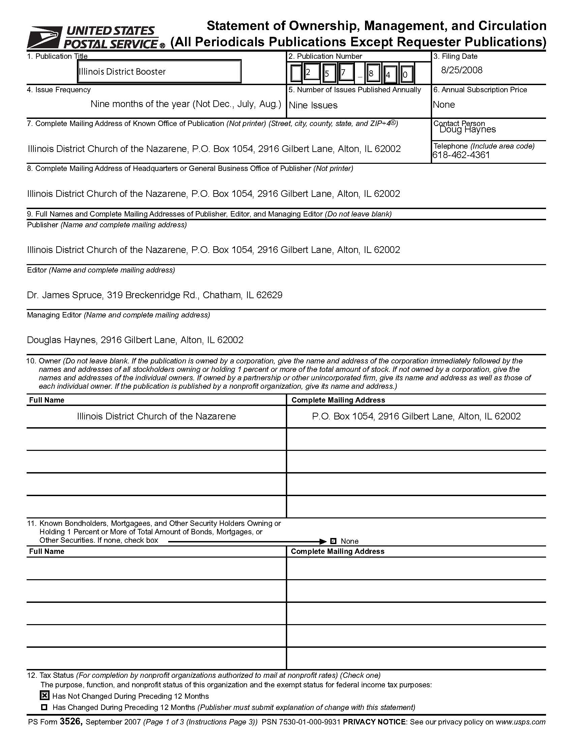
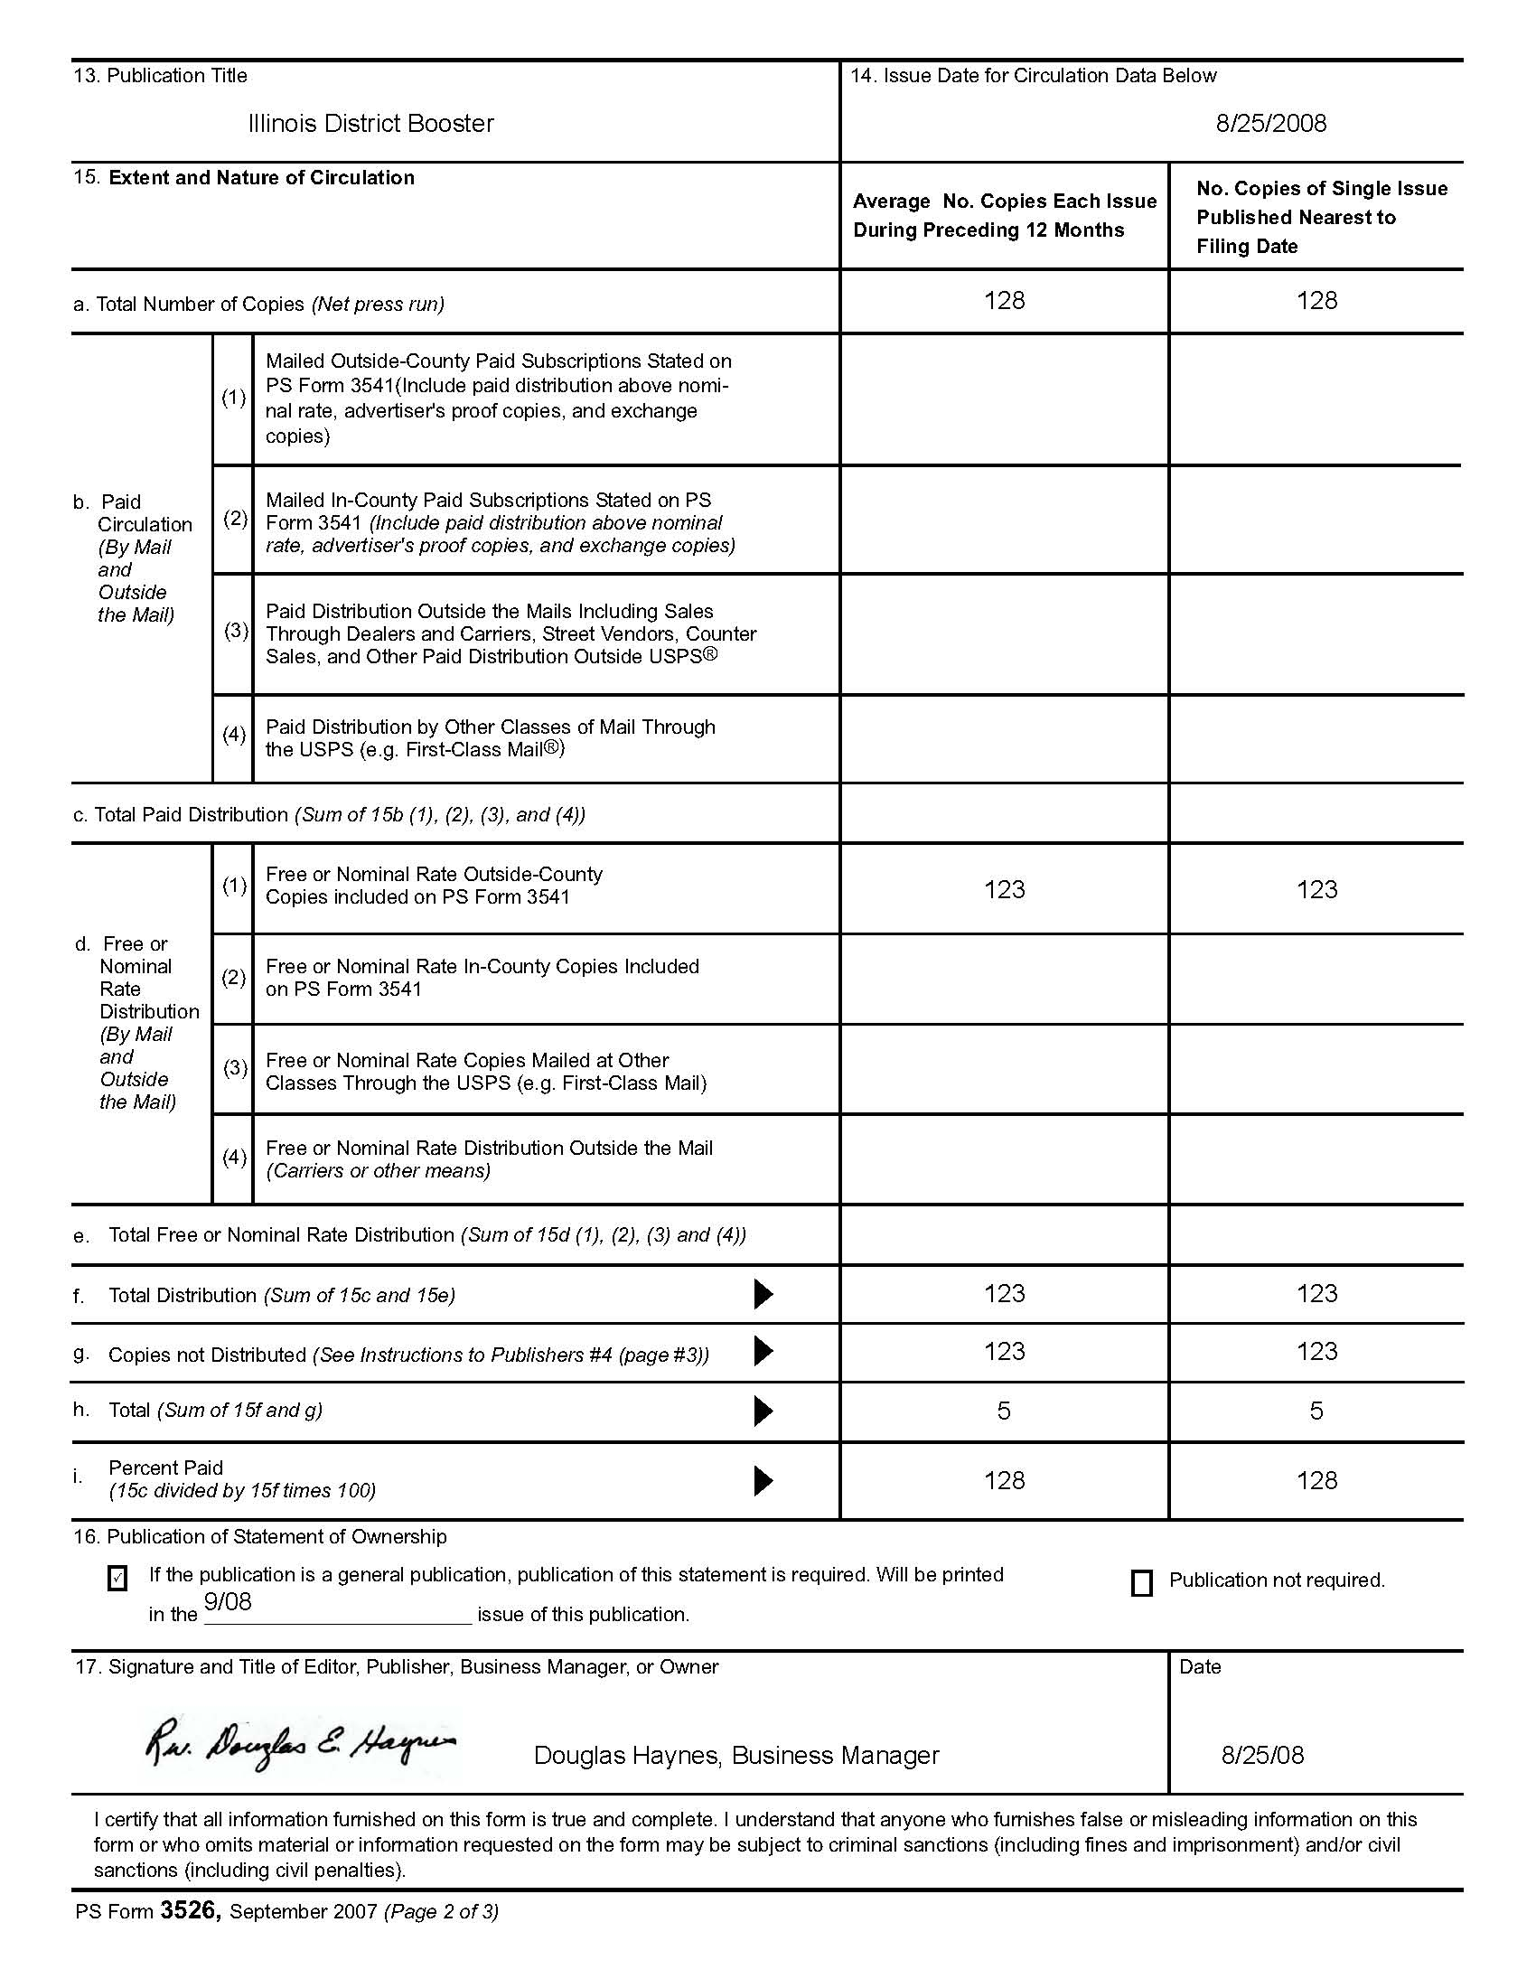
Dr. & Mrs. Allen Dace
celebrated their 55th
wedding anniversary
on Aug. 29th.
Their address is: 282 S. Stadium Dr., Bourbonnais, IL 60914

Pastors check out the following website for a seminar on conflict management in Chicago on Oct. 28 at the Parkview Community Church: www.nccba-gc2.com .

